Capstone – Loan App

TECHNICAL DESIGN DOCUMENT

|  |  |
| --- | --- |
| **Author** | *[*Professor Krasso – Brooks*]* |
| **Last Updated** | 7/9/2023 9:14 AM |
| **Version Number** | *[0.1.0]* |

**Version History**

|  |  |  |  |
| --- | --- | --- | --- |
| Name | Date | Reason for Change | Version |
| *Brooks* | *07/08/2023* | *New document format* | *1.0.0* |
|  |  |  |  |
|  |  |  |  |
|  |  |  |  |
|  |  |  |  |
|  |  |  |  |
|  |  |  |  |
|  |  |  |  |
|  |  |  |  |
|  |  |  |  |

Table of Contents

SECTION 1: INTRODUCTION 3

1.1. Purpose 3

1.2. Terminology 3

1.3. User Personas 3

1.4. User Stories 3

1.5. Time Estimations 3

SECTION 2: PROCESS DESIGN 4

2.1. Prototypes 4

2.2. ORD (Object Relational Diagram(s) 4

2.3. NoSQL Document Diagram 4

2.4. NoSQL Data Structure 4

SECTION 3: QA TESTING 4

3.1. QA Test Plan 4

3.2. Unit Tests 4

SECTION 4: REFERENCES 5

# SECTION 1: INTRODUCTION

## Purpose

Loan_App is a free-to-use online loan calculator. Loan_App specializes in estimating your monthly payment and how much interest will be paid through the term of the loan.

## Terminology

|  |  |
| --- | --- |
| **Name** | **Comments** |
| *MEAN Stack* | *MongoDB, Express, Angular, and Node.js* |
| *VS Code* | *Development IDE* |
| *SoapUI* | *API testing tool* |
| *MongoDB Compass* | *Database development IDE* |
| *Angular Material* | [*https://material.angular.io/*](https://material.angular.io/) |
| *Flex-layout* | [*https://github.com/angular/flex-layout*](https://github.com/angular/flex-layout) |

## User Personas

Gary, 68, recently retired, looking to downsize his home. He’s looking to find somewhere near the city so he can be around all his kids and grandkids.

Tech Requirements: Gary has a low computer literacy understanding.

Goals/Wants: To live closer to his family.

Lisa, 55, is looking to get into renting out a second home to rent out as a second source of income.

Tech Requirements: She has a moderate level of computer understanding.

Goals/Wants: Wants to use the load app to figure out what her monthly payment estimate would be.

Ethan, 34, looking to get into his first home. He’s using the app to create a budget for him and his wife.

Tech Requirements: He has a good understanding of computer literacy and wouldn’t expect any issues using an online application.

Goals/Wants: To see how a new home would fit into their budget.

## User Stories

Gary –

As a consumer, I would like an easy app to estimate monthly payments.

As a homeowner, would like to know how much interest has been paid on my loan.

As a beginner computer user, I would like a contact page, so that I can reach out if I need help.

Lisa –

As a homeowner and landlord, I want to calculate what my monthly payments will be.

As a homeowner and landlord, I want to check how much of my interest has been paid.

As a business owner, I want to know who I can contact for support or guidance if needed.

Ethan –

As a first-time homeowner, I would like an app with an about page to help me learn more about the app and what it can do for me.

As a new homeowner, I would like to estimate my monthly payment.

As a new homeowner, I would like a contact page to reach out for help if I need any.

## Time Estimations

## 

|  |  |  |
| --- | --- | --- |
| User Story | Story Points (1,2,3,5,8) | Time Estimation |
| As a consumer, I would like an easy app to estimate monthly payments. | 8 | 4hrs |
| As a homeowner, would like to know how much interest has been paid on my loan. | 8 | 4hrs |
| As a beginner computer user, I would like a contact page, so that I can reach out if I need help. | 3 | 1.5 hr |
| As a homeowner and landlord, I want to calculate what my monthly payments will be. | 8 | 4hrs |
| As a business owner, I want to know who I can contact for support or guidance if needed. | 3 | 1.5hr |
| As a first-time homeowner, I would like an app with an about page to help me learn more about the app and what it can do for me. | 3 | 1.5hr |
| As a new homeowner, I would like to estimate my monthly payment. | 8 | 4hr |
| As a new homeowner, I would like a contact page to reach out for help if I need any. | 3 | 1.5hr |

# SECTION 2: PROCESS DESIGN

## 2.1. Prototypes

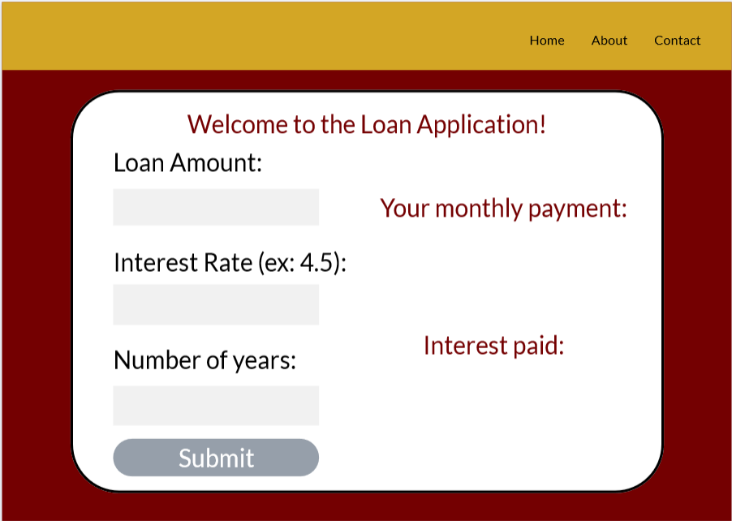

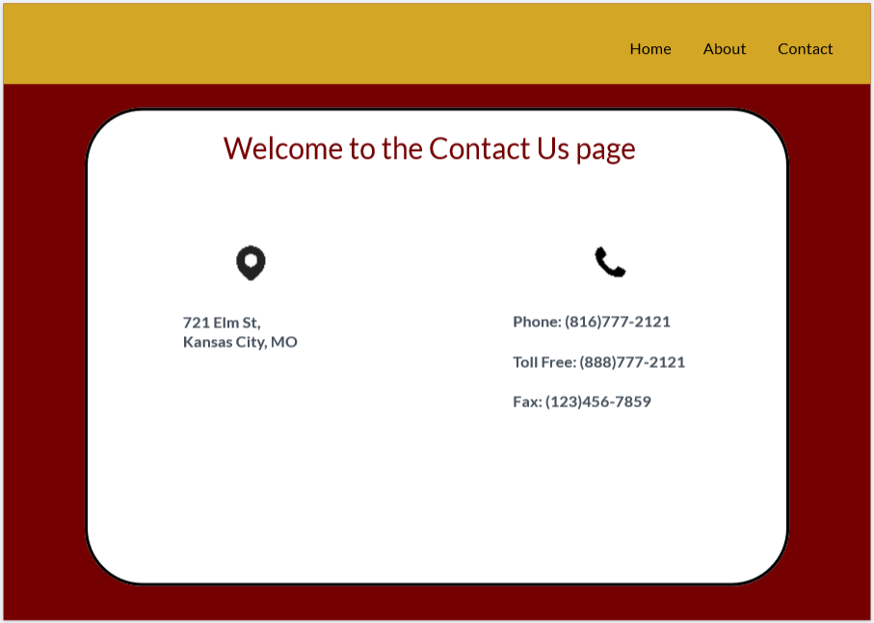

## 2.2. ORD (Object Relational Diagram(s)

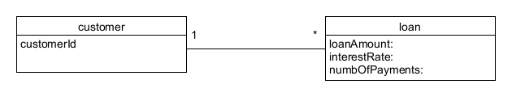

## 2.3. NoSQL Document Diagram

*[Covert the above ORD into a NoSQL Document Diagram]*

## 2.4. NoSQL Data Structure

{

“customer”: [

{

“loanAmount”: “”;

“interestRate”: “”;

“numofPayments”: “”;

}

]}

# SECTION 3: QA TESTING

## 3.1. QA Test Plan

*[Weekly Test Cases]*

## 3.2. Unit Tests

*[Images of SoapUI Unit Tests]*

# SECTION 4: REFERENCES

*[APA Reference List]*